Advanced Engineering Mathematics, by Erwin Kreyszig 10th. Ed.

**Problem Set 9.7**

No. 1







No. 2







No. 3







No. 4









No. 5







No. 6









No. 7







No. 8









No. 9











No. 10



Since



Likewise  





No. 11









No. 12











No. 13











No. 14









No. 15







 

No. 16







The direction from  to the origin

 

P on the coordinate axes.

No. 17







The direction from  to the origin

 

P on the x-and y- axes.

No. 18







At  

No. 19







At  



No. 20







At  





No. 21







At  



No. 22







The x-component is equal to zero 

And if the flow directs upward,, then ,is any integer number.

No. 23

The y-component is equal to zero,,is any integer number.

No. 24

 

 At point P 

No. 25

 



At point P 



No. 26

 



At point P 

No. 27

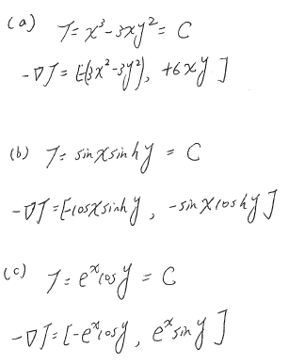

No. 28





 The direction of steepest ascent  Or 

No. 29

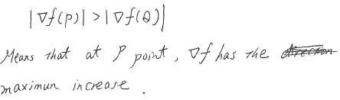

No. 30







No. 31







No. 32



 At point P

No. 33





 

No. 34





 

No. 35





 

No. 36

 



At point 



No. 37

 



At point 



No. 38

 



At point 



No. 39



grad





At point 



No. 40



grad

At point grad



No. 41



grad

At point grad





No.42





At pointgrad



No. 43

find



No. 44

find



No. 45

